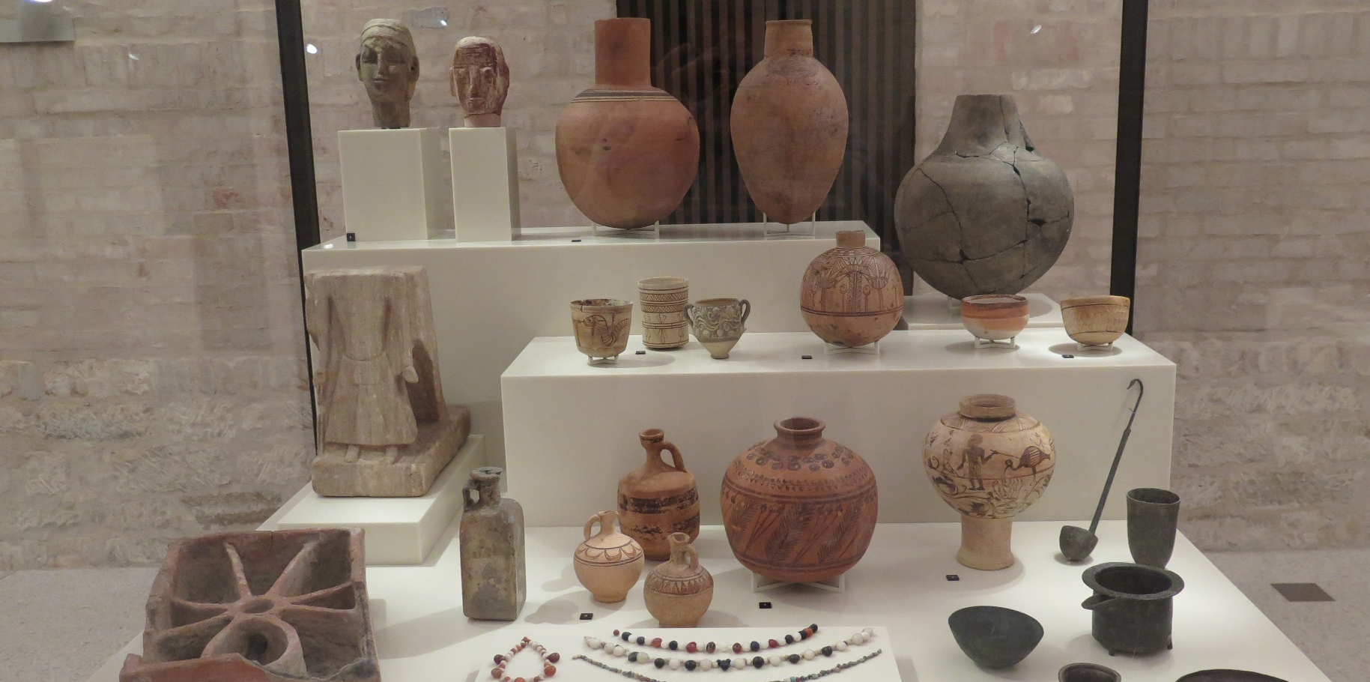

Stories across borders
Reimagining Sudan’s distant and lost heritage

Participatory workshops
May 2026

Call for Participants
The project ‘Stories across borders’ explores how museum collections can connect to memory, identity, and lost heritage in times of war and displacement. Focusing on the Ancient Nubia collection at the Ägyptisches Museum und Papyrussammlung in Berlin, it uses objects as triggers for personal and collective memories among Sudanese communities in exile.
In the context of Sudan’s ongoing conflict, the project reimagines the museum as a space to remember and reconnect with displaced heritage. Through workshops with Sudanese participants in Berlin, objects and archives become prompts to recall places, traditions, and meanings that may now be distant or lost.
By integrating memories, narratives, and artistic responses, the project aims to create more inclusive and emotionally resonant interpretations. The final outputs, including films, digital displays, and a documentary, will link museum objects to contemporary experiences of exile and identity, while challenging traditional museum narratives and highlighting the role of heritage in sustaining a sense of belonging.
What we’ll do together
- Gather around museum objects and archival images
- Share memories, stories, and personal reflections
- Discuss connections to places, traditions, and identity
- Contribute ideas and material for a documentary and digital outputs
- Provide a place for the creation of personal outputs

Details
- Dates: 4–16 May 2026
- Start: Wednesday 6 May, at the Neues Museum on the Museum Island, at 3pm. Meeting point: the historic entrance on the north east side of the building.
Drop-ins are also possible at a later time upon presentation of this invitation!
- Behind the scenes in the Neues Museum: Monday 11 May, between 10am and 3pm.
- Location: Neues Museum & Archaeological Centre, Geschwister-Scholl-Straße 6, D-10117 Berlin
Exact timings for further sessions will be confirmed with participants and can be organised according to personal availability. While some sessions will be open to a broader group, the final outputs will be developed with a small, selected group for practical and logistical reasons.
No background is required, just interest and openness to share.
If you’d like to join or know someone who might, get in touch! Tell a friend or email: ilona.regulski@gmail.com
Supported by the Agency for International Museum Cooperation with funding from the German Federal Foreign Office
